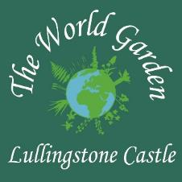

World Garden Passport Visitor Application

Please complete your details (Block Capitals)
Name(s)

Email (optional – complete if you wish to be added to our mailing list)

Number of World Garden Passports required

1 Year Single Passport - £35

1 Year Couple Passport - £50

1 Year Family Passport - £65

Please hand in your completed form at Lullingstone Castle on your next visit and pay the World Garden passport fee on the gate (cash/card) during normal opening hours.

